I am here to document adding more navigation regarding Food Posts and users. By this, I mean:

When seeing Food Posts in a profile or in the My Reservations page, you should be able to click on the Food Post’s title or picture to go to the details of that Food Post.

You should also be able to click on the Username of the creator of a Food Post to go to their profile.

This was honestly a struggle because it can sometimes be hard to work around with Blazor Components since they don’t always allow for a lot of versability with attributes like onClick, bind, href and etc. However, I managed.

If we start by the User Profile:

If you click on either the title or the picture of a Food Post, you will now navigate to the page of that Food Post’s details.

When you click on the picture, you call the method GoToFoodPost with that Food Post’s Id.



It was also important to set, with styling, the cursor to a pointer to give the User more of an idea that he can click on the picture.

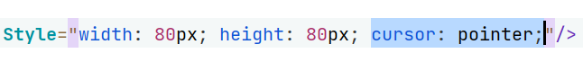

The “GoToFoodPost” method is pretty simple:

The same went for the Food Post’s title:

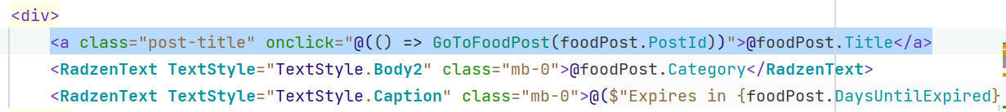

The same applies in the MyReservations page:

The Food Poster address is not being successfully fetched nor their contact number, but it is not my responsibility to deal with that.

Also, inside a Food Post details, you can also click on the creator’s username to be taken to their profile page.

All of this makes it easier to navigate within our application without being logged out for manually writing a URL lol-